School of Management

Coursework Submission Sheet

Student name | % |  | %
Ritwik Singh

Department (e.g. Management): Management
Programme and Year of Study: MSc Business Analytics 2023-24
Name of lecturer: Fotios Petropoulos

Unit title and code: MN50751 Business Statistics and Forecasting

Number of pages in assignment: 16 Word count: 4209

Declaration

I certify that I have read and understood the entry in the relevant Student Handbook for the School of Management on Cheating and Plagiarism and that all material in this assignment is my/our own work, except where I have indicated with appropriate references. I agree that, in line with Regulation 15.3(e), if requested I will submit an electronic copy of this work for submission to a Plagiarism Detection Service for quality assurance purposes. I also confirm that the percentage allocation of work is as shown above.

Upload your coursework via the Unit’s Moodle Page by the specified submission date and time. For Moodle submissions, this form should be available on Moodle site for the relevant unit and can be pasted onto the front page of your assignment if requested by your tutor. Copies are also available from Management Reception.

You should aim to hand your work in before the deadline given by your lecturer/ tutor. The University guidelines on penalties for late submission are as follows:

Any assessment submitted late without an agreed extension, will receive a maximum mark of 40% or the relevant pass mark. Any assessment submitted more than 5 working days without an agreed extension will receive a mark of zero.

For all Moodle Submissions, your marks and feedback should be returned to you via Moodle.

All work is internally moderated. For all work that contributes towards a final degree classification, a sample of work with supporting documentation for each unit is sent to an External Examiner for review and comment.

Please note that any mark given is provisional and is subject to confirmation by the relevant Boards of Examiners for Units, Programmes and Boards of Studies. These normally take place at the end of each Semester.

CONTENTS

- Executive Summary…………………………………………………………………. 3
- Introduction………………………………………………………………………….. 3
- Manual Modelling…………………………………………………………………… 3
  - Data Visualization and Exploration…………………………………………...3
  - Time Series Plot……………………………………………………………….3
  - Seasonal Decomposition………………………………………………………4
  - Augmented Dickey Fuller (ADF) Test………………………………………...5
  - Analysis of Autocorrelation and Partial Autocorrelation……………………...5
- Autocorrelation Function (ACF)…………………………………...6
- Partial Autocorrelation Function (PACF)………………………….6
  - Shapiro-Wilk Test……………………………………………………………...7
  - Simple Linear Regression Analysis……………………………………………7
  - Residual Analysis………………………………………………………………8
  - Exponential Smoothening (ETS)……………………………………………… 9
  - Auto Regressive Integrated Moving Average (ARIMA)………………………12
- Batch Forecasting……………………………………………………………………....14
  - ETS Model Selection…………………………………………………………..14
  - ARIMA Model Selection………………………………………………………14
  - Time Series Validation…………………………………………………………14
  - Benchmark Forecasting Strategies……………………………………………..15
- Conclusion……………………………………………………………………………...16
- References……………………………………………………………………………... 16

EXECUTIVE SUMMARY

This report is a thorough investigation into time series forecasting that works, mostly concentrating on M3[[1909]]. It uses a two-track methodology that combines manual modelling techniques with automated approaches such as ARIMA and ETS. The report is organised into several steps, starting with manual modelling, and ending with statistical testing, data visualisation, and investigation to identify important trends and dependencies. The next step in applying Exponential Smoothing (ETS) is to choose the best models and provide forecasts. Then, we carefully examine Auto Regressive Integrated Moving Average (ARIMA) models to make sure parameter selection is in line with the complexity of the data.
Batch forecasting, where customised ETS and ARIMA models beat benchmark methods and provide a strong forecasting solution, is the focus of a large amount of the paper. The "ETS or ARIMA" method stands out as being especially successful and accurate.
The report, in its whole, focuses on the managerial implications, emphasizing the critical role that precise forecasting plays in choices related to production, inventory control, and marketing. It recommends flexibility in dynamic business situations, integration of topic knowledge, and ongoing model validation.
The research does, however, note a number of limitations, including potential problems with data quality, assumptions about stationarity, and vulnerability to outside influences. Notwithstanding these limitations, the goal of the paper is to provide decision-makers with a comprehensive grasp of time series forecasting that is especially suited to the changing business environment of M3[[1909]].

INTRODUCTION

In dynamic decision-making, time series forecasting efficiency is essential. With a focus on series M3[[1909]] from the M3 competition, this study explores predicting approaches. In addition to automated batch forecasting for 100 series, dual-track exploration includes human techniques like data exploration and linear regression. Accurate demand estimates are the aim, along with improving M3[[1909]] service delivery, production scheduling, marketing, and inventory control. The report employs automated statistical forecasting and batch modelling to provide decision-makers with comprehensive insights. It highlights the critical role that precise forecasting plays in supply chain optimisation, competitive advantage, and flexible operational planning within the business environment.

MANUAL MODELLING

Data Visualization and Exploration
Extracting and organizing the statistics covering January 1981 to December 1992 is the first step in the procedure, which allows for a thorough understanding of monthly production trends. Examining the features of the historical data is a crucial first stage, where descriptive statistics provide information about variability and key tendencies. A minimum production of 3296 units, a median of 5038 units, and a maximum of 5990 units are highlighted in the summary data. Throughout this time, the glass container industry's average monthly production was roughly 4876 units, with an interquartile range of 4563 to 5190. This shows how important variability and central tendencies are for forecasting and making strategic decisions.

Time Series Plot: "In manual (or expert) forecasting, a combination of graphical representations and statistical summaries of the data are used to determine important features of the series such as trend and seasonal patterns. A forecaster then selects and estimates models that utilize these features to predict future values." (Chapter 8.1.1) A meticulous arrangement of the January 1981 – December 1992 information reveals patterns in monthly production. A maximum output of 5990 units, a median of 5038 units, and a low of 3296 units are shown by summary statistics, which provide an overview of variability and key trends. The interquartile range is 4563 to 5190 units, with a monthly average of 4876 units. The diversity and important trends that are crucial for forecasting and making strategic decisions in the glass container business are highlighted in this report.

A time series plot below is used to generate a visual representation in order to better understand the production dynamics:

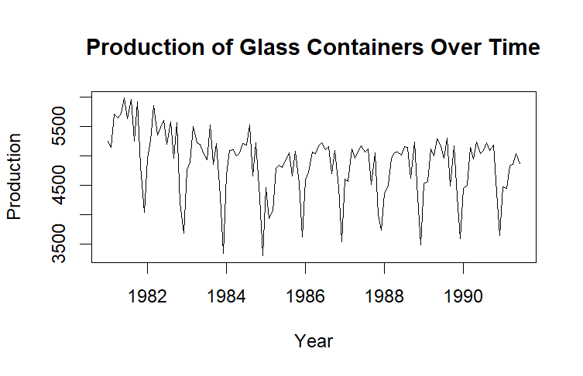

The monthly output levels are depicted in this plot, which shows a slightly declining trend.

Seasonal Decomposition: A decomposition analysis was carried out to examine the underlying patterns in the historical data in more detail. Through this method, the time series is broken down into its component parts—trend, seasonality, and residual factors.

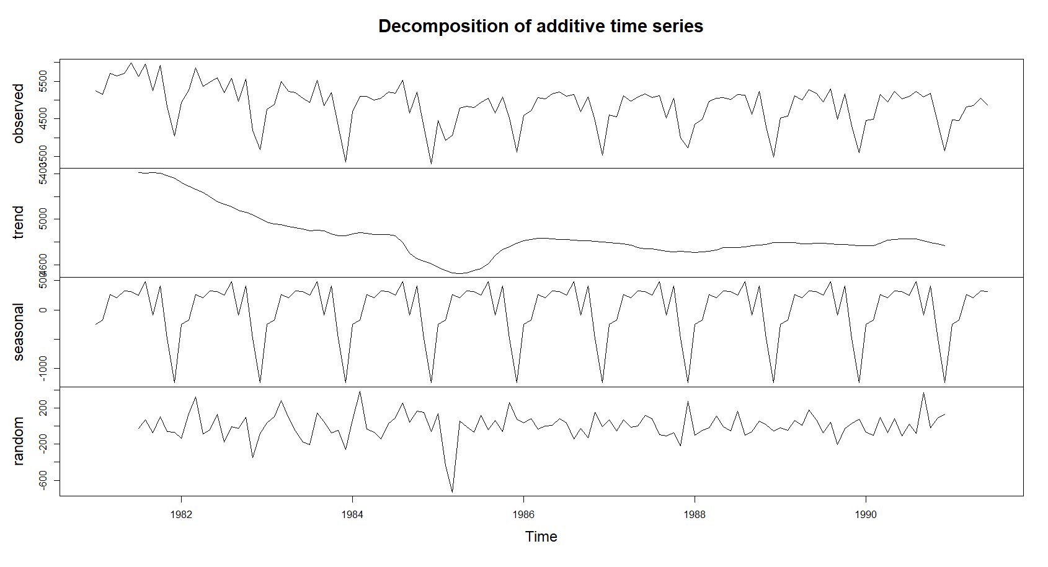

The plot() function that followed produced the following visualisations:

Original Time Series Plot: General direction and swings.
Trend Component Plot: Shows the trajectory or long-term orientation.
Seasonal Component Plot: Cycles or recurring patterns.
Remainder(Residuals) Plots: Unaccounted-for variance after trend and seasonality are taken into consideration.
This method helps with forecasting, demand planning, and operational strategy decisions by
offering a clear and insightful analysis.

Augmented Dickey Fuller (ADF) Test: A key component of precise forecasting is ensuring the time series' stationarity. The existence of unit roots, a crucial sign of non-stationarity which was evaluated using the ADF test. The ADF test findings indicate that the historical data is stationary, with:
- p-value: 0.01
- Lag Order: 4
- ADF Test Statistic: -5.2042

The time series is assumed to be non-stationary and to have a unit root in the Augmented Dickey-Fuller (ADF) test's null hypothesis. According to the alternate theory, the time series is stationary. We reject the null hypothesis with a p-value of 0.01, which is less than the conventional significance level of 0.05. The conclusion that the historical time series is stationary is strongly supported by this. One of the most important factors in time series analysis is the stationarity of a time series. Making use of a stationary time series helps streamline the modelling process and enable more accurate forecasts. This work provides important insights into the properties of the historical time series and establishes the groundwork for time series modelling and forecasting in the future.

Analysis of Autocorrelation and Partial Autocorrelation: Making informed decisions in domains like demand forecasting, resource allocation, and strategy planning requires a thorough understanding of temporal interdependence. Understanding the time-based factors that can affect future results through autocorrelation pattern analysis allows for more precise and efficient decision-making.
Plots of the Partial Autocorrelation Function (PACF) and the Autocorrelation Function (ACF) were created to examine temporal dependencies in the historical data and reveal possible lagged correlations between observations.

Autocorrelation Function (ACF): This calculates the correlation coefficient between a time series and its lagged values at various intervals. Strong correlation between observations separated by a given lag is indicated by a significant ACF value at that lag.
In the context of series M508, the ACF plot helps to highlight the temporal connections and links within the production data.
Positive or negative extensions outside the confidence intervals signify a high degree of autocorrelation at specific delays. This is necessary to determine the seasonality and overall temporal structure of the industry-specific time series.

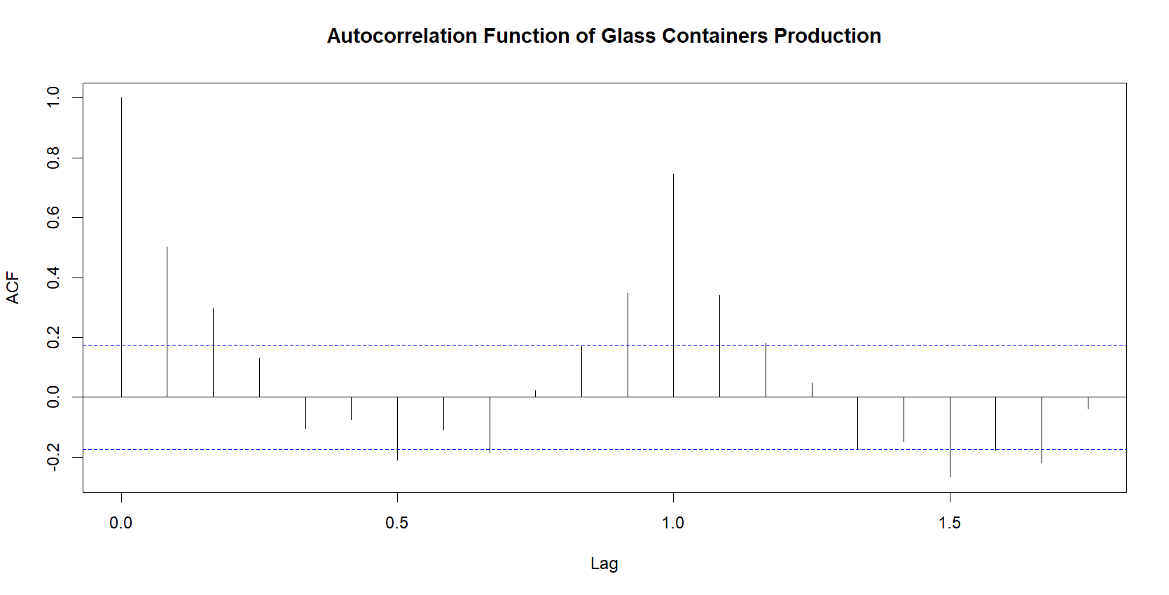

A spike outside the blue confidence range at lags in the ACF plot denotes a considerable amount of autocorrelation at those lags. Given that these lags correspond to possible multiples of a seasonal cycle, this implies that there may be a seasonality component in the data.

Partial Autocorrelation Function (PACF): By eliminating the impact of intermediate observations, PACF concentrates on the direct relationship between an observation and its lag values. Significant PACF values at specific lags show that observations at those intervals are directly dependent upon one another. Each bar on the PACF figure indicates the correlation between the series at time t and the series at a specific lag, without taking into consideration the effect of the lags in between.
Finding clear links between data gathered at various times is one area in which PACF excels. In respect to series M508, the PACF plot facilitates the identification of putative intrinsic patterns by differentiating lags that exhibit notable partial autocorrelation.

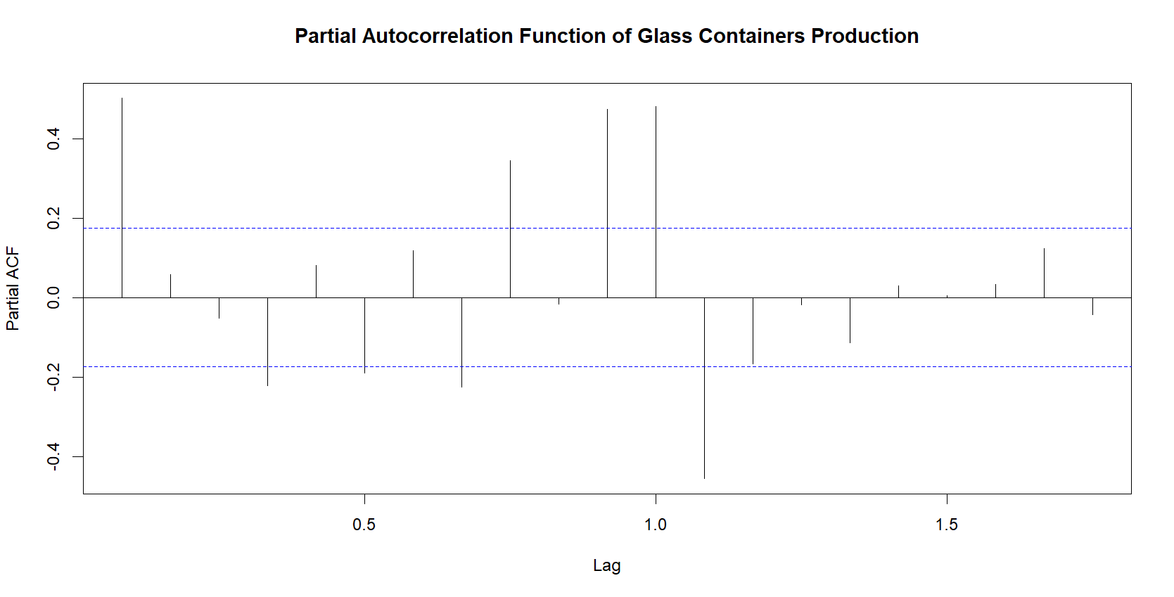

Spikes at lags in the PACF graphic indicate considerable partial autocorrelation at these delays. A possible autoregressive (AR) component can be identified by the presence of significant partial autocorrelation at lag 1, although spikes at higher lags might point to a more intricate autocorrelation structure.

Shapiro Wilk Test: Utilizing the Shapiro-Wilk normality test, the historical data was assessed for conformity to a normal distribution.
- W statistic: 0.94015
- p-value: 2.844e-05

It is clear from the computed p-value (0.00002844) that the historical data does not follow a normal distribution and hence strongly contradicts the hypothesis of normalcy. It is critical to identify this deviation from normalcy since it may impact further studies, and procedures will need to be modified to account for the distinctive characteristics of the data.

Simple Linear Regression Analysis:
To comprehend the relationship between historical data and time-related predictors, particularly a linear time trend and seasonal impacts, the analysis uses a basic linear regression model. The main objectives and conclusions of this analysis are as follows:
- Identifying Trends Over Time: The model considers how values change over time to capture patterns and trends seen in historical data.
- Understanding Coefficients: The quantitative impact of time-related predictors on the historical values is revealed by the coefficients of analysis. Especially:
- The predicted value of historical values when seasonality and time trend are both zero is the intercept (4909.7486).
- The predicted change in historical data for a one-unit increase in time is indicated by the trend coefficient (-4.3300).
- Seasonal coefficients (season 2 through season 12) show the anticipated alterations related to each season.
- Significance of Statistics: Asterisk-designated significance levels aid in the identification of predictors that have a major influence on past values. Greater evidence opposing the null hypothesis that the coefficient is zero is shown by lower p-values.
- Fit and Variability of the Model: The residual statistics (Min, 1Q, Median, 3Q, Max) offer insights into the model's error distribution. The percentage of historical value variability that can be accounted for both seasonality and the linear temporal trend is shown by the R-squared value (0.8212).
- Overall Model Significance: The F-statistic's incredibly low p-value (< 2.2e-16) indicates that the model, considering both predictors, is statistically significant.
The methodology accounts for both seasonal influences and a linear time trend by quantifying the changes in historical values over time. A thorough comprehension of the relationships is provided by the coefficients and statistical tests, which can offer insightful information for making decisions.
The historical data clearly exhibits temporal patterns, which motivate the use of a basic linear regression model with a time trend and seasonality. With its easily understandable coefficients, this model provides insight into the quantitative effects of time-related elements. Its simplicity makes it a sensible option for forecasting and decision-making since it strikes a balance between readability and adequate explanatory power. The model provides insights on periodic seasonal patterns and systematic changes throughout time, but it also acts as a starting point for further investigation. Validation against performance metrics guarantees the effectiveness and durability of the model.

Residual Analysis:
The code computes the residuals, or the differences between the values predicted by the regression model and the observed values, in residual analysis. Next, a plot of these residuals against the fitted values—that is, the values the model predicted—is made. This plot is meant to serve as a visual evaluation tool for how well the model represents the patterns in the data.
The residuals are then subjected to three normality tests. To determine whether the residuals exhibit any systematic patterns, the Durbin-Watson test assesses the residuals' independence. In this instance, autocorrelation in the residuals is suggested by a low p-value and a low Durbin-Watson statistic.
The residuals' normality is evaluated using the QQ (Quantile-Quantile) plot. The residuals' distribution is plotted against the normal (bell-shaped) distribution's predicted distribution. The plot displays line-by-line point alignment along the red reference line, suggesting a normal distribution for the residuals. The Shapiro-Wilk test, which yields a low p-value and further suggests that the residuals vary from a normal distribution, supports this visual evidence.

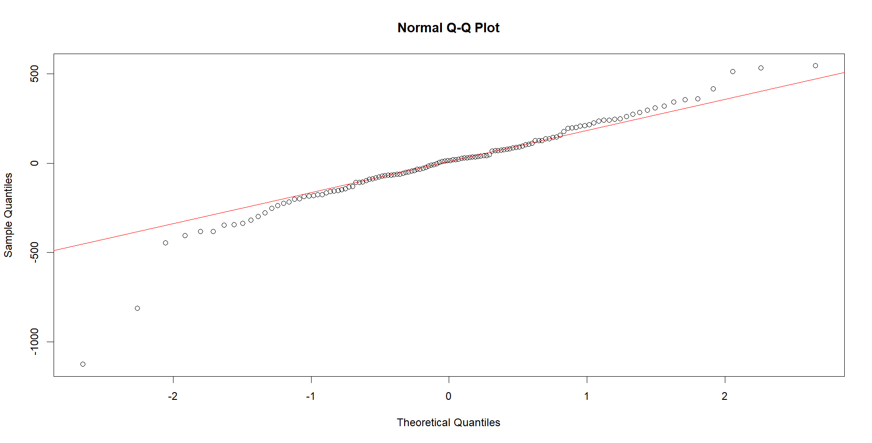

Finally, heteroscedasticity—a condition in which the variability of residuals is not consistent across all levels of the independent variable—is evaluated for using the Breusch-Pagan test. The p-value of 0.3395 in our instance indicates that there is not any conclusive proof of heteroscedasticity.

Test | Statistic | p-value
Durbin-Watson Test | DW = 0.73059 (Independence) | 3.69E-12
Shapiro-Wilk Test | W = 0.93798 (Normality) | 2.02E-05
Breusch-Pagan Test | BP = 13.416 (Equal Variance) | 0.3395

All these tests work together to provide a thorough assessment of the regression model, guaranteeing that the independence and normalcy assumptions are met. Our confidence in the residuals' normality—a critical component for the linear regression model's dependability—is strengthened by the QQ plot's alignment with the reference line.

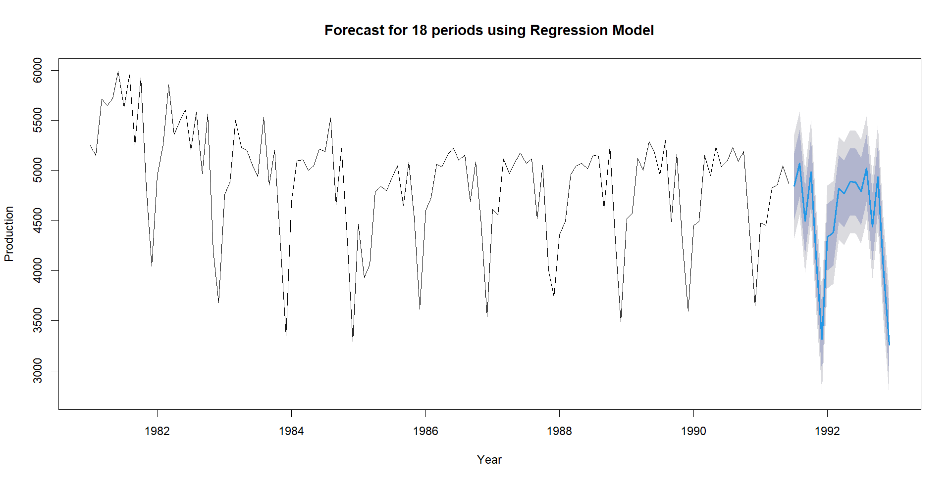

Exponential Smoothening (ETS):
The code describes how different Exponential Smoothing (ETS) models are applied to historical data to produce precise projections for the ensuing eighteen periods. A summary of each model is provided, together with key features and performance indicators derived from the training data. Here is a concise overview:

- ETS(A,N,N) Model (fit1): This model uses a smoothing parameter (alpha) of 0.5983 to accurately represent the level of the historical data. The prediction has a residual standard deviation (sigma) of 519.0811 and is based on the historical level. The mean error (ME) of -5.372658, the root mean square error (RMSE) of 514.9449, and the mean absolute error (MAE) of 402.5346 are the model's performance measures.

- ETS(A,A,N) Model (fit2): The model alpha and beta parameters are 1e-04 and 0.5941, respectively, combining level and trend. There are two beginning states: trend (-4.09) and level (5618.8295). RMSE = 515.8583, MAE = 407.5551, and ME = -2.67016 are the model's performance measures.

- ETS(A,Ad,N) Model (fit3): This model, which damps the level and trend components (phi = 0.8), has alpha = 0.5952 and beta = 1e-04. The initial states are 50.1525 for the trend and 5523.1801 for the level. ME = -11.02225, RMSE = 515.4557, and MAE = 404.1769. These are the model's performance measures.

- ETS(A,Ad,A) Model (fit4): This model, with alpha = 0.3449, beta = 1e-04, gamma = 1e-04, and phi = 0.9738, has seasonal components as well as a dampened trend. Level (5593.2328), the mellowed trend (-24.7558), and seasonal elements are the initial states. ME = -1.505985, RMSE = 170.8591, and MAE = 123.9627 are some of the model's performance measures.

- ETS(M,Ad,M) Model (fit5): This model, which includes a dampened trend and multiplicative seasonality, has alpha = 0.3148, beta = 1e-04, gamma = 1e-04, and phi = 0.979. Level (5587.6915), dampened trend (-24.4524), and multiplicative seasonal components are the initial states. The model's performance parameters are as follows: MAE = 121.995, RMSE = 167.4453, and ME = 3.746109.

Model | Components | Parameters | Initial States | Performance Metrics
ETS(A,N,N) | Level | α = 0.5983 | l = 5301.8019 | ME = -5.3727, RMSE = 514.9449, MAE = 402.5346
ETS(A,A,N) | Level, Trend | α = 0.5941, β = 1e-04 | l = 5618.8295, b = -4.09 | ME = -2.6702, RMSE = 515.8583, MAE = 407.5551
ETS(A,Ad,N) | Level, D.Trend | α = 0.5952, β = 1e-04, φ = 0.8 | l = 5523.1801, b = 50.1525 | ME = -11.0223, RMSE = 515.4557, MAE = 404.1769
ETS(A,Ad,A) | Level, D.Trend, Seasonal | α = 0.3449, β = 1e-04, γ = 1e-04, φ = 0.9738 | l = 5593.2328, b = -24.7558, s = ... | ME = -1.5060, RMSE = 170.8591, MAE = 123.9627
ETS(M,Ad,M) | Level, D.Trend, Multi.Seasonal | α = 0.3148, β = 1e-04, γ = 1e-04, φ = 0.979 | l = 5587.6915, b = -24.4524, s = ... | ME = 3.7461, RMSE = 167.4453, MAE = 121.995

The optimal model, "fit5," is then selected, and its use is applied to generate forecasts for the subsequent 18 periods, assisting future corporate decision-making as below:

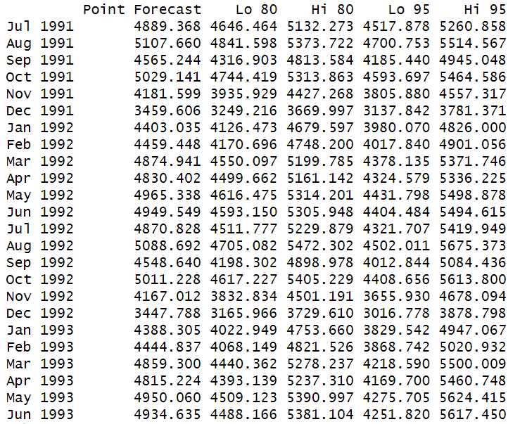

The point forecast for fit5 is shown in the table along with lower and higher confidence intervals at the 80% and 95% levels. The prediction is valid from July 1991 to June 1993. The projected values are represented by the point prediction, and the range within which the actual values are anticipated to fall with a given degree of confidence is provided by the confidence intervals. Insights into the accuracy of the forecast are provided by the 80% and 95% confidence intervals, which assist stakeholders in making defensible judgements considering deviations from the estimated values.

It can be graphically represented as follows:

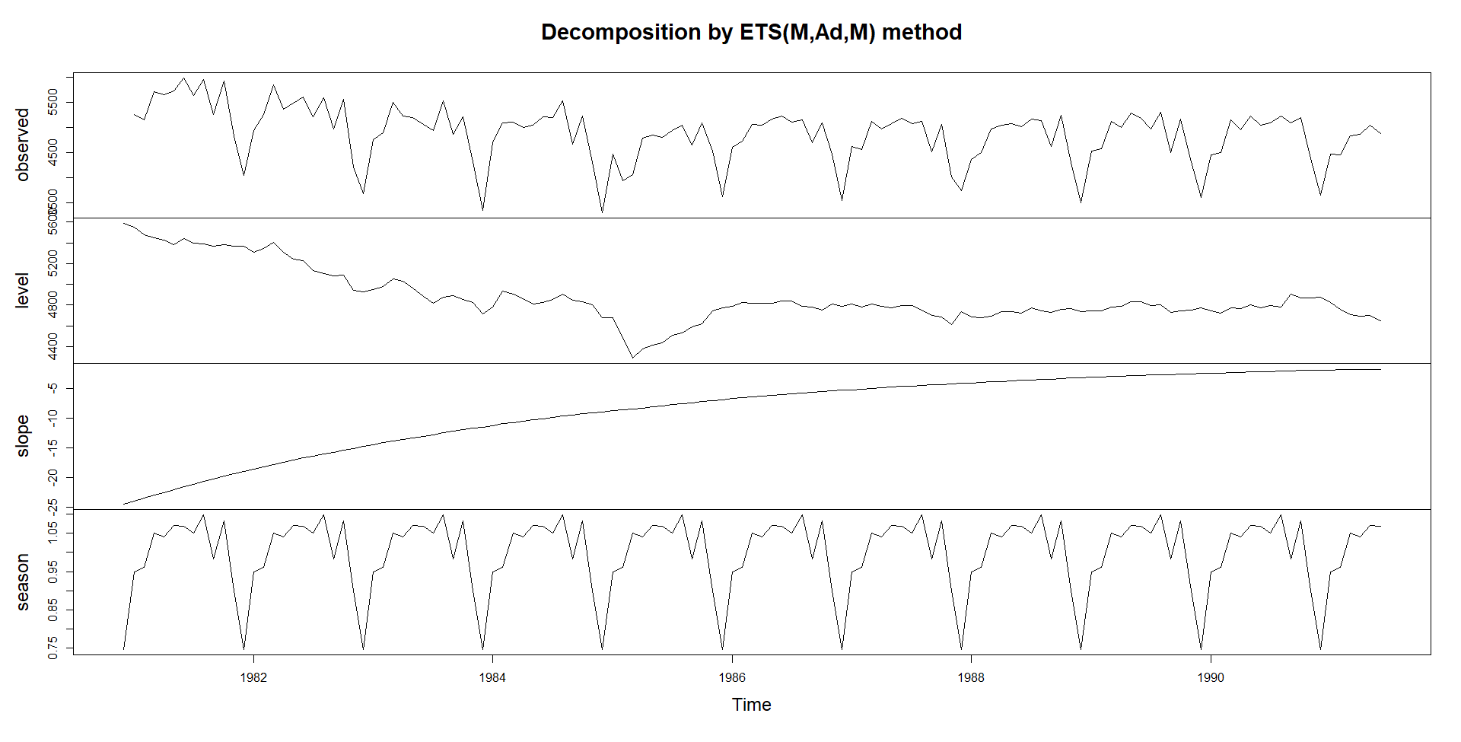

Auto Regressive Integrated Moving Average (ARIMA):
This model considers three main components: Auto Regressive (AR), Integrated (I), and Moving Average (MA). The AR component models the relationship with past values, the I component handles differencing to achieve stationarity, and the MA component captures short-term fluctuations.
The code begins a thorough investigation of ARIMA models by specifying parameter sets that include different non-seasonal (p, d, q) and seasonal (P, D, Q) orders. Every ARIMA model is fitted to historical time series data using a methodical evaluation loop, and the Akaike Information Criterion corrected for small sample sizes (AICc) is computed for every model. The set with the lowest AICc is used to determine which ARIMA model is the best. The selected model is then refitted, and a thorough summary is given along with coefficients, errors, and different goodness-of-fit metrics. This procedure makes it possible to investigate ARIMA configurations in detail, guaranteeing that the model that is chosen strikes a delicate balance between simplicity and correctness.
The code determines which model is best based on the lowest AICc value after evaluating each model. A summary of the model's coefficients, standard errors, log likelihood, AIC, AICc, BIC, and training set error measures (ME, RMSE, MAE, MPE, MAPE, MASE, ACF1) is then given once the final ARIMA model is fitted with the ideal parameters.
A first-order difference in the seasonal component and a first-order difference in the non-seasonal component, together with a moving average term in both components, offer an excellent fit to the historical data, according to the chosen ARIMA(0,1,1)(0,1,1)[12] model. Performance metrics of the model on the training set are also provided.

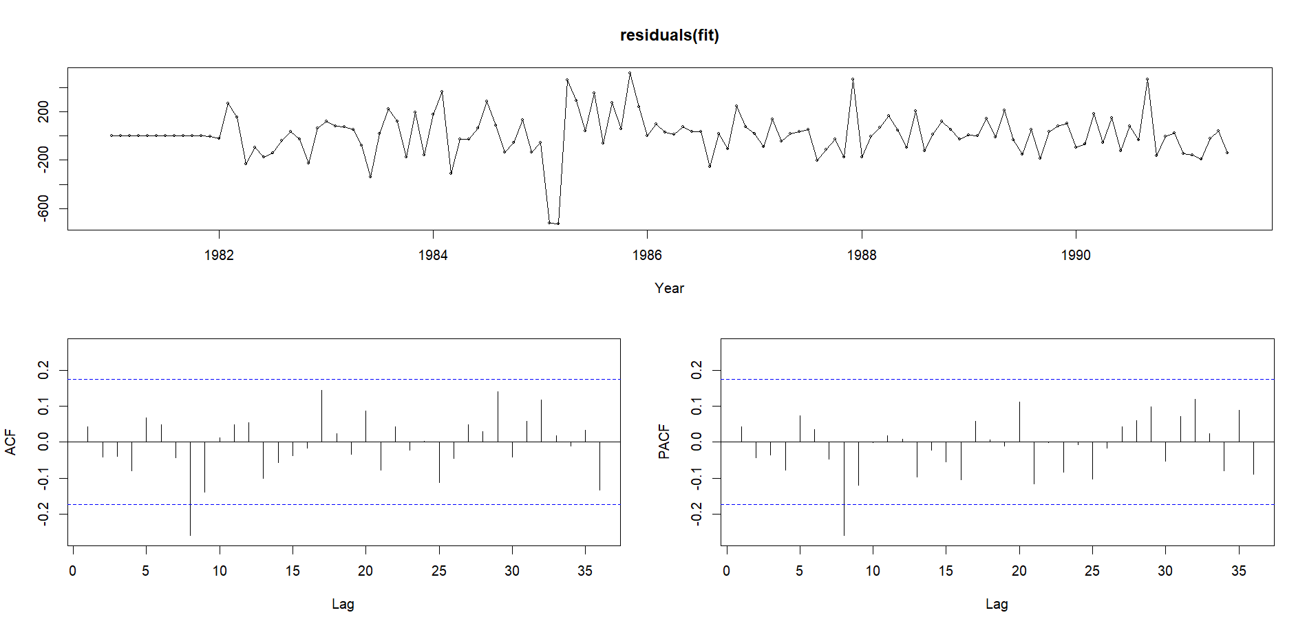

The ARIMA model's residuals are analyzed and shown by the code. Using tsdisplay, it looks for patterns and autocorrelation in the residuals. The code also produces forecasts with forecasts for future time points. This procedure supports forecasting performance evaluation and model validation.
In order to determine whether white noise exists, we will also run the Ljung-Box test. The calculated p-value of 0.1534 indicates that there is insufficient evidence to reject the null hypothesis that there is no autocorrelation in the residuals, as it is bigger than the significance level of 0.05.

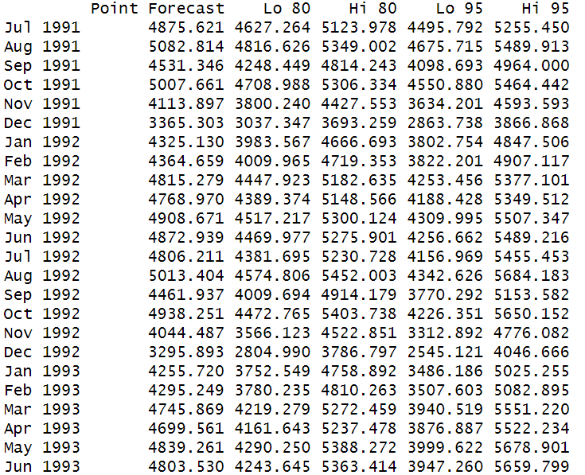

It can be graphically represented as:
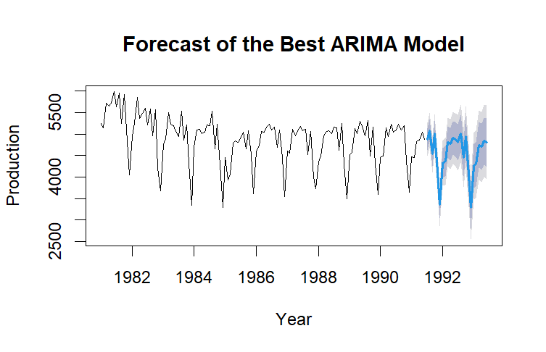

BATCH FORECASTING

The report uses ARIMA model selection and Exponential Smoothing (ETS) to provide unique insights into the temporal patterns of the data. Additionally, a customized model selection approach is shown, which considers in-sample data to identify the best forecasts for any single series.
This thorough analysis includes a thorough review procedure, which elevates it above conventional predicting techniques. The purpose is to evaluate the customized strategy and the ETS and ARIMA models' predicted accuracy in comparison to widely used benchmark techniques such as Mean, Seasonal Naive, and Naive strategies. Several error measures are applied over different planning horizons in the performance evaluation process to account for various time series features, including seasonality and trends.
The goal of this thorough investigation is to offer an in-depth understanding of the advantages and disadvantages of each forecasting technique, facilitating wise decision-making in the field of time series prediction.

ETS Model Selection:
The objective of the ETS (Exponential Smoothing) model selection method is to use the forecast package for ets() function to automate the process of choosing the best model for each of the 100-time series associated with the student ID. To determine the best configuration for precise forecasting, this method looks at several combinations of the error, trend, and seasonality components inside the Exponential Smoothing framework.
The error (E), trend (T), and seasonality (S) are the three primary factors considered in the ETS model. Various combinations of these elements, including additive seasonality, multiplicative trend, and additive error, are evaluated by the automated method. The Akaike Information Criterion corrected (AICc), which helps find the model that best combines goodness of fit and model complexity, is the basis for model selection.
The ETS model intends to automate this process to give a methodical and data-driven approach to model selection, enabling more effective and efficient forecasting across a variety of time series data related to the Student ID.
Using ETS models, the code forecasts several time series in a methodical manner to help evaluate accuracy on an individual and aggregate level. When comparing the forecasting performance of the ETS strategy and making decisions, the mean MAPE, MAE, and RMSE offer aggregated insights that are essential.

ARIMA Model Selection:
The principal objective of utilizing the auto.arima() function to apply the ARIMA model is to speed up choosing the best model for time series forecasting. To balance the model's complexity and goodness of fit, this automated method considers a variety of data patterns, such as trends and seasonality. Its advanced algorithms enable it to offer a precise and effective framework for forecast generation, making it suitable for users of different skill levels and flexible enough to work with a variety of datasets.

Time Series Validation:
In this part, a forecasting approach is implemented that dynamically chooses between the ARIMA and ETS models for each time series based on how well each model performs in terms of Mean Absolute Percentage Error (MAPE). Below is a summary of the essential steps:
A dynamic forecasting strategy is used by the code, which switches between the ETS and ARIMA models for each time series according to how well their Mean Absolute Percentage Error (MAPE) performance indicates. Iterating over time series, dividing data into training and validation sets, assessing ARIMA and ETS models, choosing the best-performing model, forecasting using the selected model, and computing performance metrics (MAPE, MAE, RMSE) for each series are some of the crucial processes.
MAPE (Mean Absolute Percentage Error) is frequently used in forecasting evaluations, it is selected as the main evaluation metric for the ARIMA and ETS forecasting models. It provides a lucid, percentage-based depiction of prediction accuracy, making it easy to understand and compare across different time series. Although there are alternative metrics that offer useful insights into forecast accuracy, such as Mean Absolute Error (MAE) and Root Mean Squared Error (RMSE), the choice for MAPE may be due to its established utility and significance in forecasting literature and practice. The intended focus of the forecasting study and certain data characteristics frequently have an impact on the selection of measures.
Using the chosen technique, the output yields information about the average forecasting accuracy over the whole dataset. As complete measures, the mean MAPE, MAE, and RMSE are used to evaluate the effectiveness of the combined ETS and ARIMA forecasting approach.

Across several time series, the use of mean techniques—such as Mean Absolute Percentage Error (MAPE), Mean Absolute Error (MAE), and Root Mean Squared Error (RMSE)—provides a thorough assessment of the forecasting accuracy. These metrics provide information about several facets of model performance, including comprehensive indicators for evaluating the efficacy of the combined ETS and ARIMA forecasting approach are the mean MAPE, MAE, and RMSE.

- MAPE: The average absolute difference between the expected and actual values is measured, expressed as a percentage, using the Mean Absolute Percentage Error (MAPE). When analysing forecasts' relative accuracy, MAPE is a useful tool, particularly when working with variables that have varied sizes.
- MAE: The average absolute difference between the numbers that were anticipated and those that were obtained is determined by the Mean Absolute Error, or MAE. The mean average error magnitude (MAE) is a simple, easy-to-understand metric.
- RMSE: By measuring the square root of the average squared discrepancies between the anticipated and actual values, the Root Mean Squared Error, or RMSE, highlights greater errors. When bigger errors have more serious repercussions and must be penalized appropriately, RMSE is especially helpful.
Metric | ETS Strategy | ARIMA Strategy | ETS or ARIMA Strategy
Mean MAPE | 14.27293 | 14.89242 | 13.97919
Mean MAE | 513.7498 | 516.4865 | 499.1514
Mean RMSE | 603.3285 | 611.5083 | 592.215

In the table above, greater forecast accuracy is shown by lower values for RMSE, MAE, and MAPE. The combined strategy produces more accurate forecasts overall, as evidenced by the fact that the "ETS or ARIMA Strategy" performs better than the individual ETS and ARIMA strategies in each of the three measures.
The unique properties of the time series data and the forecasting objectives determine which of ETS and ARIMA is preferable. By combining the advantages of both approaches, the combined technique may provide a more reliable and adaptable approach that enhances forecasting performance overall.

Benchmark Forecasting Strategies:

In time series forecasting, benchmark techniques serve as essential reference points that provide a starting point for assessing more complex forecasting models. The effectiveness of the three main benchmarks—the Mean, Seasonal Naive, and Naive strategies—in forecasting time series data is evaluated in this section. Strategic decision-making is aided by the comparative examination of these benchmarks, which sheds light on how well sophisticated forecasting techniques function.

Forecasting Strategy | Mean MAPE | Mean MAE | Mean RMSE
ETS | 14.27 | 513.75 | 603.33
ARIMA | 14.89 | 516.49 | 611.51
ETS or ARIMA | 13.98 | 499.15 | 592.22
Naive | 17.88 | 647.6 | 768.09
Seasonal Naive | 16.97 | 627.63 | 762.49
Mean | 28.27 | 970.18 | 1064.51

In summary, the "ETS or ARIMA" method performs better than or about the same as the other strategies taken into consideration when it comes to forecasting accuracy, according to the metrics that have been presented.

CONCLUSION
With the help of automatic models such as ETS and ARIMA, as well as human methodologies, the report offers a dual-track investigation of time series forecasting. Laying the foundation are insights from residual analysis, linear regression, and manual modelling. In batch forecasting, the "ETS or ARIMA" approach surpasses both individual techniques and benchmarks, demonstrating its resilience. Although it highlights important developments in the sector, the study has limitations due to assumptions about stationarity and external variables.
Managerial Implications: Production, inventory control, and marketing all benefit from accurate forecasting, which is essential for decision-making. Managers must be aware of the requirement for ongoing model validation as well as external uncertainty. Although forecasting offers insightful information, subject knowledge should be integrated into strategic decisions, and flexibility is essential in dynamic commercial settings. The study emphasizes the value of a cooperative and flexible approach to strategic planning and provides managers with the tools they need to make well-informed decisions.
Limitations:
- Stationarity Assumption: The models assume of stationarity, which leaves out the possibility of changes in the dynamics of the market or outside influences affecting the behaviour of the series over time.
- External Influences: Events outside the realm of historical data, such as those that are political, economic, or unanticipated, may have a major impact on forecasting accuracy.
- Data Quality: The accuracy of forecasts is dependent upon the calibre of previous data. The accuracy of forecasting could be harmed by errors or missing data.
- Model Complexity: Although ETS and ARIMA provide advanced forecasting, non-experts may find it difficult to understand and apply due to its complexity.
- Single Series Focus: The study's primary focus is on the M3[[1909]] series, which restricts its applicability to a variety of datasets and sectors.

REFERENCES

- Petropoulos, F., Makridakis, S., Assimakopoulos, V. and Nikolopoulos, K. (2014). ‘Horses for Courses’ in demand forecasting. European Journal of Operational Research, 237(1), pp.152–163. doi:https://doi.org/10.1016/j.ejor.2014.02.036.

